Antiholomorphic function

Intro

It can be considered as the holomorphic function to conjugate complex number $$conj\left(z\right)$$

For more details about holomorphic function, see my notes “holomorphic function.docx”

Def

From Wiki

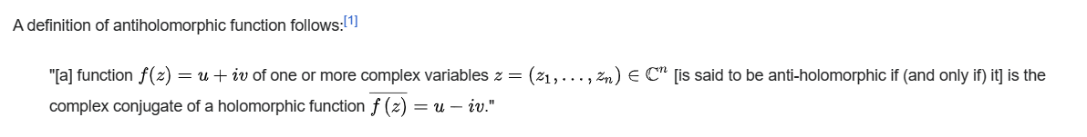

Ref

[Antiholomorphic function - Wikipedia](https://en.wikipedia.org/wiki/Antiholomorphic_function)